Analyze proproposal gathering members to discuss proposal, onc we agree on a minimum level, we discuss the proposal with the official.

Even if EU don’t have an army/real coordinates policy is still one of the most influential bodies in the word. It has an influence that comes from unified policy and regulation. EU also biggest market in the word, producer companies and non-eu state want to design their own regulation they can try directly with no barriers.

GDPR prompted similar in other part of the world, comanda (social media…) are already in compliance.

**How the EU works?**

EU commission. Executive branch of EU ∪ established 1957. Composed of 27 commissioners representing member state + president (Ursula) act in the general EU interest, have indipendente from Eu state.

EU parlament. Have intuitive to propose laws.

The commission hve power to insure comeption + compl

Commission receives application of EU laws and implement with the budget. Manage programs founded (like earsmus) represent the Eu during itnrantional meeting.

Structure

Commission policing departement, specific director. Manly in Bruxelles,

Eu parlament. Propert legislative branch eu parlament only directly elected body. One of largest democracy assemble. 700 members represent EU citizens, elected once ever 5 years buy voters from the 27 states. MPS = members the number of mps in each state is determine by the size of the citizens in the city. MPs divided divided by different political ideas, politics are divided in groups

EU parlament share +compl

EU parlament can give/withow then+compl

Exercise power control over eu activity. Highlight something to eu commission I write a note to eu commission.

EU council. Decision making situation, meaning tending by the minister of 27 country. There are differen session, each eu member state have turn to share and being the president of the council. 10 configurations, depending of it there are different miniseries of the same state attending.

Coreper.

Corepher 1 and 2.

Coreperh 1 refers all other countries configuration.

Most cases council decision are based on proposal from the commission are taken togheter.

Join adoption by eu parlament + council. Made on proposal of a commission. Commission make proposal.

EU parlament and council adopt new laws. When it comes to specific legislative act we have a directive addressed to eu member states. Directive not immedialty applicabile to all eu state. Each country needs to determine how to incorporate it o a law. S called transposition max of 2 years to make it.

When a member state does not transpose a new law, commission might initiate infringement commission.

Italy strict legislation about ownership of firearms. Can not own firearms and huns. Then the eu pass directive that had to b transpose, italia legislation become more libera. Now can own classico

Minimum standard might be against direction of the state.

Regualtion applies immediately without the need to be transped in nationa laws, then have rights and obligations to individuals.

Delegated acts adopted by eu commission to supplement elements. The delegated act can not change the essential elements of the delegated act.

The commission consulte experts form EU state before adopting acts. Usually done when they need to be adapted with technical / scientific project. In order to have legislation might need delegated act.

All members have to agree to pass reolutions? They have to agrees simple majority.

Internailioal treaty must be implement in national legislation. To accept it it determines is rank.

——

Everything is public information. You can try to engage when you believe that something is already in existence. Could be improve/adapted.

EU AI ac proposed by the eu commission. Discussed olly be passed/adopted next year. It s a moment when lobbyist can ijtervene?

There is a procedure can influence, knowing the ordinary legislative procedure.

Reduce production waste of smart h phone. Company that produce smartphone have follow rules.

Initiative that aims considering substeniability principe more and more. + digitalisation

**EUROPEAN COMMISSION (executive, propose laws):**

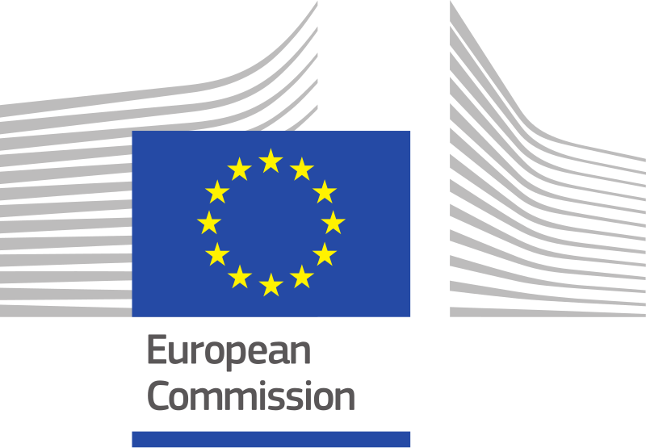

Main executive body of EU

Runs the day-to-day work, checks whether member state are keeping to existing laws and propose new EU laws (that always needs to be approved by the Parliament and/or council of the EU)

1 President + 7 Vice-President (one of whom is First-Vice-President) + 20 commissioner = College of commissioner.

The EU Council proposes a president for the commission, if he is elected by the parliament he proposes 27 candidates for the other seat in the council of commission. Parliament then chooses to elect it (each country has one commissioner, it should work for the interest of the EU and not for the interest of his country).

Meets 1 a week in Bruxelles to discuss current issues.

* Work programs: full consensus
* Vote: simple majority (all commissioner have one vote, regardless of the title)

The commission is the only institution allowed to propose new laws. After which the council and parliament may adopt them (ordinary legislative procedure). The Commission monitors the application of the law, if a member fails to incorporate EU laws to national laws or if a memer is suspected of breaching the EU law, it can refer it to the EU court of justice (but usually not necessary).

Before proposing legislation the commission takes stock of existing laws and conduct impact assessment to evaluate the potential economic, social and environmental consequences of any new initiative

Is the closest thing to a government in the EU. 28 people of the college of commissioners are not directly elected by the people but they need to be approved by the EU parliament

**EUROPEAN PARLIAMENT (legislative)**

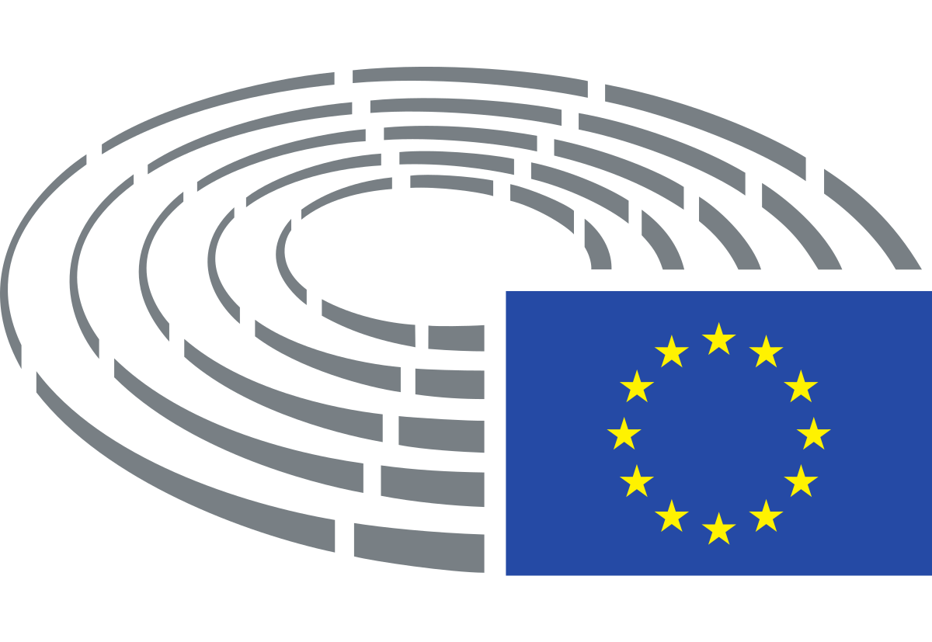

Largest transnational democratic electorate and second largest democratic election (after India). 751 members, headed by one president and 14 vice-president. Seats are defined among member states proportionately to their population. (min of 6 max of 96). Every 5 years meps are elected in their country and sent to Brussels where they are grouped in party among the same ideological lines.

Work of parliament take place in 3 different countries

* Amministrative work: Luxembourg
* Plenary meeting 3 weeks every month: Bruxelles
* Plenary meeting 1 week every month: Strasburg

EU parliament have three main tasks

* **Legislative power**: All proposals for EU legislation must be checked by parliament. Can choose to approve, amend, or reject a proposal.
* **Budgetary power**: The EU budget must be approved by parliament before money can be spended. Have to say both before and after money is spent
* **Control over the executive branch (The Commission)**: Check that the executive branch does not get too powerful. It can cast a vote of no-confidence and fire the college of commissioners. Voting is done by simple show of hands or electronic vote. Simple majority usually (at least one in favor). An important decision needs an absolute majority. For no-confidence vote needs 2/3 of voting members in favor

**EUROPEAN COUNCIL**

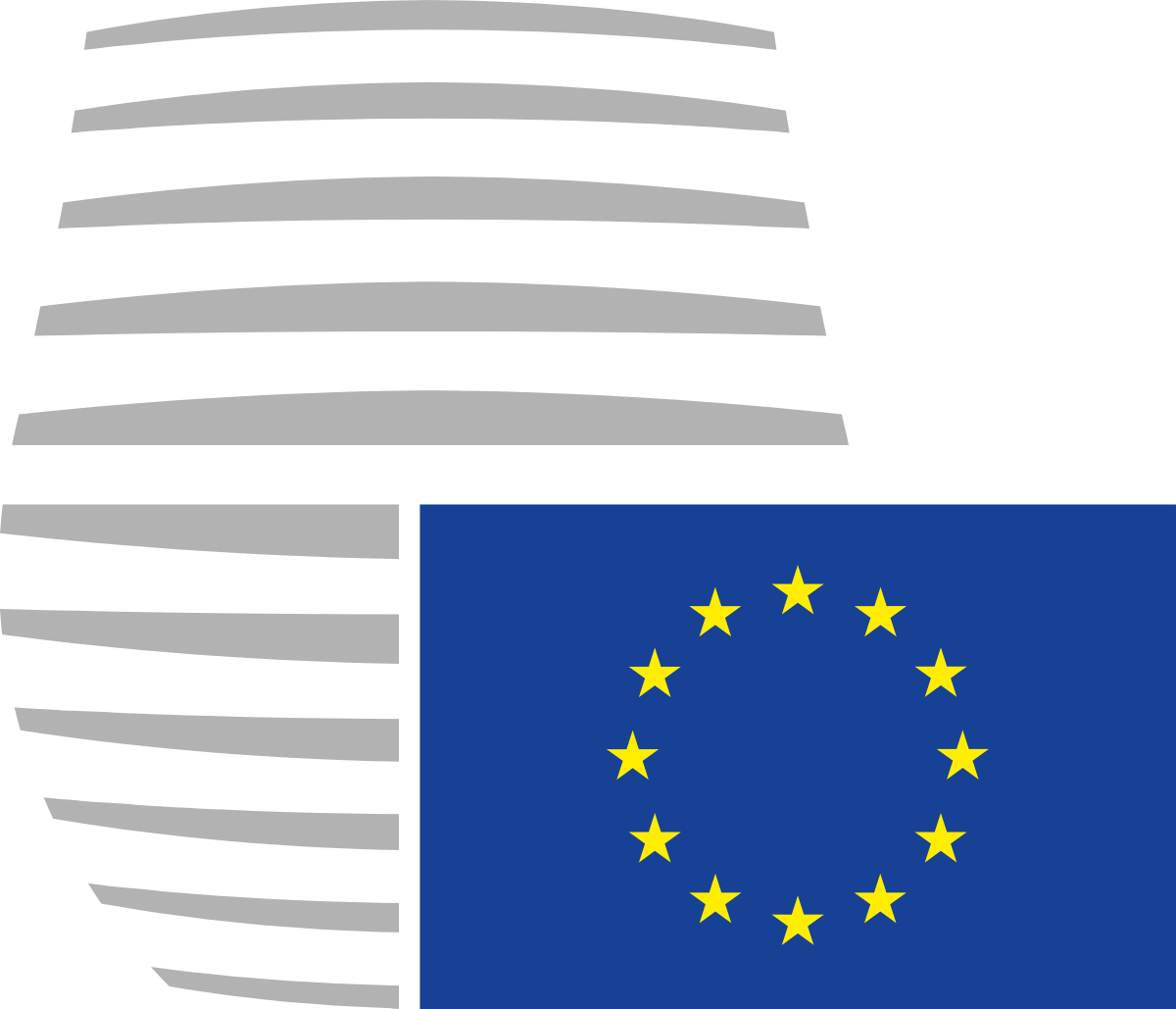

(aka council of ministers/the council).

Is the representation of the governments of the member states. 28 ministers (one for each state). The council has a different composition depending on the subject (all minister of all the 28 state responsible for agriculture and fisheries comes together at the EU agriculture and fishery council)

It makes decisions by a qualified majority (a decision must be supported by 55% of the ministers of the countries representing at least 65% of the EU population). In some cases needed unamility

Decision only pass if when the parliament also signs off

COREPER I: deputy heads of missions, deals largely with social and economic issues

COREPER II: heads of missions. Deals largely with political, financial and foreign policy issues

Tasks:

* **Legislative power**: all proposals for EU laws must be checked from the council. Can choose to approve, amend or reject
* **Budgetary power**: must be approved from EU council before money can be spended
* **Foreign affairs**: decides on common foreign and security policy (CFSP)